Validation for SelectTs is failed

JSON Message-

{"_id":"CustomerPreferences_3f47af31-7110-499f-9f7b-010202645bc0","_class":"PreferenceAggregateStateDomain_v1","aggregateId":"{{UUID}}","aggregateType":"CustomerPreferences","state":{"_class":"PreferenceAggregateDomain_v1","createTimestamp":1571121879465,"lastUpdateTimestamp":1603443904787,"createClientId":"EDSS","lastUpdateClientId":"web-portal","createHostName":"CustomerPreferenceManagementService-Prod-2","lastUpdateHostName":"172.31.192.65","aggregateId":"UUID","aggregateType":"CustomerPreferences","sequenceNumber":35,"timestamp":1603443904773,"aggregateRevision":35,"version":1,"eventId":"b414e09d-e21f-4b05-9cc6-15f6142b3a4a","guid":"{{guid}}","preferences":[{"_class":"DeliverySubscriptionPreferenceAggregateDomain_v1","preferenceId":0,"value":"f9b88f7e-5f54-4536-afc0-8b080d189cdf","type":"MONTHLYPLAN","categoryCode":"DELIVERY","subCategoryCode":"SUBSCRIPTION","optChoices":[{"_class":"OptChoiceAggregateDomain_v1","choice":"CANCELLED"}],"effectiveTimePeriods":[{"_class":"EffectiveTimePeriodAggregateDomain_v1","type":"ACTIVE","inclusiveInd":1,"endDate":"2019-12-13","endTime":"00:00"}],"deliverySubscriptionOffer":{"_class":"DeliverySubcriptionOfferAggregateDomain_v1","serviceFeeWaived":0,"deliveryFeeWaived":1,"fuelSurchargeWaived":1,"minBasketSize":30,"fee":{"_class":"CurrencyDomain_v1","currency":"USD","amount":14.99},"initialOrderAmountOff":{"_class":"CurrencyDomain_v1","currency":"USD","amount":20},"signUpFee":{"_class":"CurrencyDomain_v1","currency":"USD","amount":14.99}},"autoEnroll":0,"autoRenew":0,"serviceType":"1"},{"_class":"BasicPreferenceAggregateDomain_v1","preferenceId":1,"value":"1515","type":"J4U","categoryCode":"ENTERPRISE","subCategoryCode":"STORE","preferredInd":0,"lastUpdatedTimestamp":1584461293000},{"_class":"BasicPreferenceAggregateDomain_v1","preferenceId":2,"value":"LC","categoryCode":"SHOPPING_LIST","subCategoryCode":"J4U","preferredInd":0},{"_class":"BasicPreferenceAggregateDomain_v1","preferenceId":3,"value":"AL","type":"ITEMS_PER_PAGE","categoryCode":"DISPLAY","subCategoryCode":"PAGINATION","preferredInd":0},{"_class":"BasicPreferenceAggregateDomain_v1","preferenceId":4,"value":"S","type":"YCS_TOP_10","categoryCode":"DISPLAY","subCategoryCode":"SORT","preferredInd":0},{"_class":"BasicPreferenceAggregateDomain_v1","preferenceId":5,"type":"1","categoryCode":"DISPLAY","subCategoryCode":"HIDDEN_CATEGORY","preferredInd":0,"optChoices":[{"_class":"OptChoiceAggregateDomain_v1","choice":"1"}]},{"_class":"BasicPreferenceAggregateDomain_v1","preferenceId":6,"type":"10","categoryCode":"DISPLAY","subCategoryCode":"HIDDEN_CATEGORY","preferredInd":0,"optChoices":[{"_class":"OptChoiceAggregateDomain_v1","choice":"1"}]},{"_class":"BasicPreferenceAggregateDomain_v1","preferenceId":7,"type":"19","categoryCode":"DISPLAY","subCategoryCode":"HIDDEN_CATEGORY","preferredInd":0,"lastUpdatedTimestamp":1584461293000,"optChoices":[{"_class":"OptChoiceAggregateDomain_v1","choice":"1"}]},{"_class":"BasicPreferenceAggregateDomain_v1","preferenceId":8,"type":"EMAIL_SAVE","categoryCode":"COMMUNICATION","subCategoryCode":"PROMOTIONAL","preferredInd":0,"optChoices":[{"_class":"OptChoiceAggregateDomain_v1","choice":"OPT_IN"}]},{"_class":"BasicPreferenceAggregateDomain_v1","preferenceId":9,"type":"J4U","categoryCode":"COMMUNICATION","subCategoryCode":"PROMOTIONAL","preferredInd":0,"optChoices":[{"_class":"OptChoiceAggregateDomain_v1","choice":"OPT_IN"}]},{"_class":"BasicPreferenceAggregateDomain_v1","preferenceId":10,"type":"GROCERY_DEL","categoryCode":"COMMUNICATION","subCategoryCode":"PROMOTIONAL","preferredInd":0,"optChoices":[{"_class":"OptChoiceAggregateDomain_v1","choice":"OPT_IN"}]},{"_class":"BasicPreferenceAggregateDomain_v1","preferenceId":11,"value":"DUG","categoryCode":"FULFILLMENT","subCategoryCode":"METHOD","preferredInd":0,"bannerId":"1","lastUpdatedTimestamp":1596507326000},{"_class":"BasicPreferenceAggregateDomain_v1","preferenceId":12,"value":"1515","type":"DUG","categoryCode":"ENTERPRISE","subCategoryCode":"STORE","preferredInd":0,"bannerId":"1","lastUpdatedTimestamp":1596507326000},{"_class":"BasicPreferenceAggregateDomain_v1","preferenceId":13,"type":"NAME_PRINTED","categoryCode":"RECEIPT","subCategoryCode":"PAPER","preferredInd":0,"lastUpdatedTimestamp":1595699991000,"optChoices":[{"_class":"OptChoiceAggregateDomain_v1","choice":"OPT_IN"}]},{"_class":"BasicPreferenceAggregateDomain_v1","preferenceId":14,"type":"GLOBAL","categoryCode":"COMMUNICATION","subCategoryCode":"PROMOTIONAL","preferredInd":0,"lastUpdatedTimestamp":1595699991000,"optChoices":[{"_class":"OptChoiceAggregateDomain_v1","choice":"OPT_IN"}]}]}}

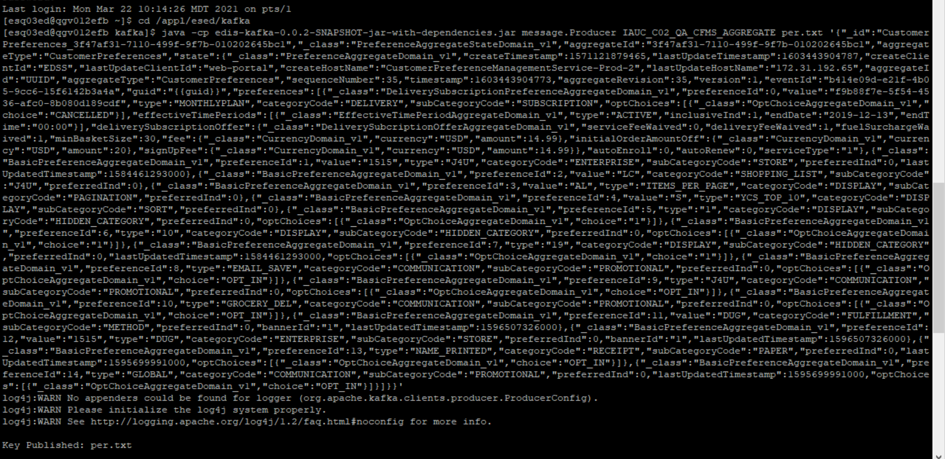

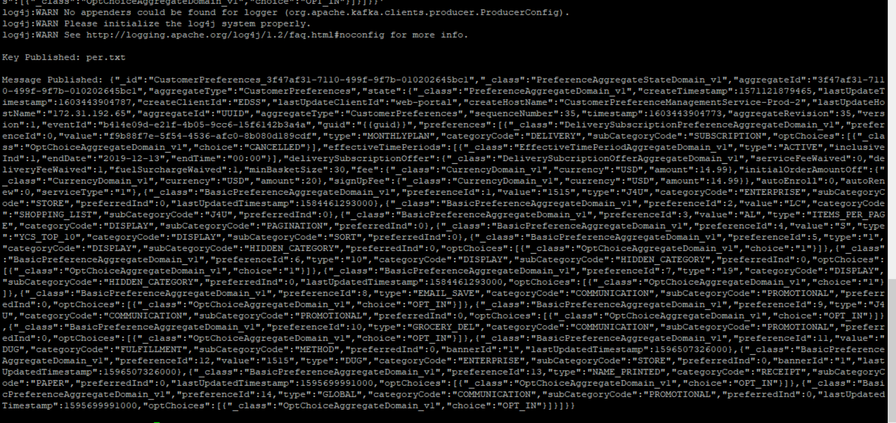



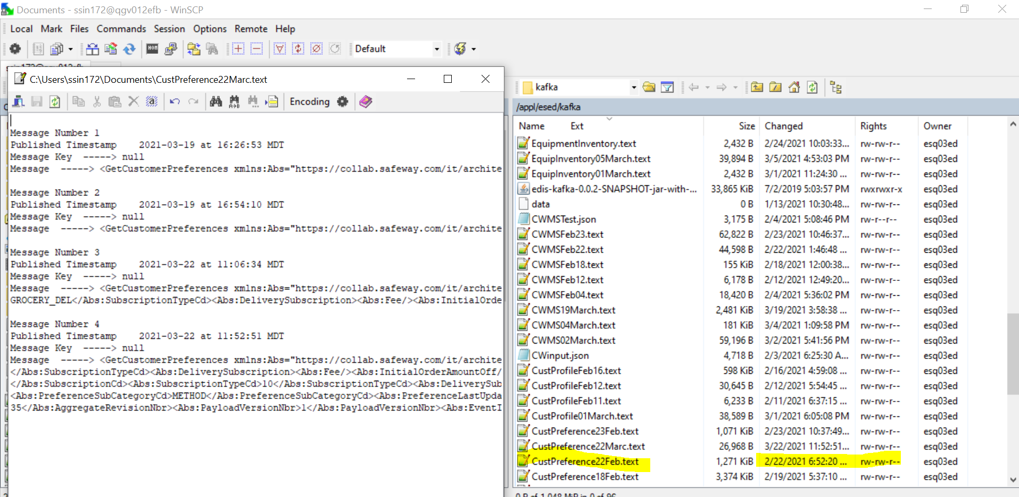

CMM XML-

<GetCustomerPreferences

xmlns:Abs="https://collab.safeway.com/it/architecture/info/default.aspx">

<DocumentData>

<Document VersionId="3.3.1.053" SystemEnvironmentCd="QA">

<Abs:DocumentID>IAUC_C02_QA_CFMS_AGGREGATE</Abs:DocumentID>

<Abs:AlternateDocumentID>IAUC_C02_QA_CFMS_AGGREGATE_1_2210_20210322115251882401</Abs:AlternateDocumentID>

<Abs:InboundOutboundInd>Outbound from Albertsons</Abs:InboundOutboundInd>

<Abs:DocumentNm>GetCustomerPreference</Abs:DocumentNm>

<Abs:CreationDt>2021-03-22T11:52:51.882401</Abs:CreationDt>

<Abs:Description>Retail customer&apos;s generic preferences and the subscriptions</Abs:Description>

<Abs:SourceApplicationCd>CFMS</Abs:SourceApplicationCd>

<Abs:TargetApplicationCd>EDIS</Abs:TargetApplicationCd>

<Abs:InternalFileTransferInd>Y</Abs:InternalFileTransferInd>

<Abs:DataClassification>

<Abs:DataClassificationLevel>

<Abs:Code>Internal</Abs:Code>

</Abs:DataClassificationLevel>

<Abs:BusinessSensitivityLevel>

<Abs:Code>Low</Abs:Code>

</Abs:BusinessSensitivityLevel>

<Abs:PHIdataInd>N</Abs:PHIdataInd>

<Abs:PCIdataInd>N</Abs:PCIdataInd>

<Abs:PIIdataInd>N</Abs:PIIdataInd>

</Abs:DataClassification>

</Document>

<DocumentAction>

<Abs:ActionTypeCd>UPDATE</Abs:ActionTypeCd>

<Abs:RecordTypeCd>CHANGE</Abs:RecordTypeCd>

</DocumentAction>

</DocumentData>

<CustomerPreferencesData>

<Abs:CustomerId>3f47af31-7110-499f-9f7b-010202645bc1</Abs:CustomerId>

<Abs:CustomerPreferences>

<Abs:PreferenceClassNm>DeliverySubscriptionPreferenceAggregateDomain_v1</Abs:PreferenceClassNm>

<Abs:PreferenceCd>0</Abs:PreferenceCd>

<Abs:PreferenceTypeCd>MONTHLYPLAN</Abs:PreferenceTypeCd>

<Abs:PreferenceVal>f9b88f7e-5f54-4536-afc0-8b080d189cdf</Abs:PreferenceVal>

<Abs:PreferenceCategoryCd>DELIVERY</Abs:PreferenceCategoryCd>

<Abs:PreferenceSubCategoryCd>SUBSCRIPTION</Abs:PreferenceSubCategoryCd>

<Abs:OptChoice>

<Abs:ChoiceDsc>CANCELLED</Abs:ChoiceDsc>

</Abs:OptChoice>

<Abs:PreferenceEffectivePeriod Abs:typeCode="ACTIVE">

<Abs:LastEffectiveDt>2019-12-13</Abs:LastEffectiveDt>

<Abs:LastEffectiveTm>00:00:00.000</Abs:LastEffectiveTm>

<Abs:InclusiveInd>1</Abs:InclusiveInd>

</Abs:PreferenceEffectivePeriod>

<Abs:CustomerSubscriptions>

<Abs:SubscriptionId>f9b88f7e-5f54-4536-afc0-8b080d189cdf</Abs:SubscriptionId>

<Abs:SubscriptionCd>SUBSCRIPTION</Abs:SubscriptionCd>

<Abs:SubscriptionTypeCd>MONTHLYPLAN</Abs:SubscriptionTypeCd>

<Abs:DeliverySubscription>

<Abs:Fee CurrencyCd="USD" FeeAmt="14.99"/>

<Abs:ServiceFeeWaivedInd>0</Abs:ServiceFeeWaivedInd>

<Abs:DeliveryFeeWaivedInd>1</Abs:DeliveryFeeWaivedInd>

<Abs:FuelSurchargeWaivedInd>1</Abs:FuelSurchargeWaivedInd>

<Abs:MinimumBasketSizeQty>30</Abs:MinimumBasketSizeQty>

<Abs:AutoRenewInd>0</Abs:AutoRenewInd>

<Abs:AutoEnrollInd>0</Abs:AutoEnrollInd>

<Abs:InitialOrderAmountOff CurrencyCd="USD" DiscountAmt="20.00"/>

<Abs:SignupFee CurrencyCd="USD" FeeAmt="14.99"/>

</Abs:DeliverySubscription>

</Abs:CustomerSubscriptions>

</Abs:CustomerPreferences>

<Abs:CustomerPreferences>

<Abs:PreferenceClassNm>BasicPreferenceAggregateDomain_v1</Abs:PreferenceClassNm>

<Abs:PreferenceCd>1</Abs:PreferenceCd>

<Abs:PreferenceTypeCd>J4U</Abs:PreferenceTypeCd>

<Abs:PreferenceVal>1515</Abs:PreferenceVal>

<Abs:PreferenceCategoryCd>ENTERPRISE</Abs:PreferenceCategoryCd>

<Abs:PreferenceSubCategoryCd>STORE</Abs:PreferenceSubCategoryCd>

<Abs:PreferenceLastUpdatedTs>2020-03-17T16:08:13.000Z</Abs:PreferenceLastUpdatedTs>

<Abs:PreferredInd>0</Abs:PreferredInd>

<Abs:CustomerSubscriptions>

<Abs:SubscriptionId>1515</Abs:SubscriptionId>

<Abs:SubscriptionCd>STORE</Abs:SubscriptionCd>

<Abs:SubscriptionTypeCd>J4U</Abs:SubscriptionTypeCd>

<Abs:DeliverySubscription>

<Abs:Fee/>

<Abs:InitialOrderAmountOff/>

<Abs:SignupFee/>

</Abs:DeliverySubscription>

</Abs:CustomerSubscriptions>

</Abs:CustomerPreferences>

<Abs:CustomerPreferences>

<Abs:PreferenceClassNm>BasicPreferenceAggregateDomain_v1</Abs:PreferenceClassNm>

<Abs:PreferenceCd>2</Abs:PreferenceCd>

<Abs:PreferenceVal>LC</Abs:PreferenceVal>

<Abs:PreferenceCategoryCd>SHOPPING_LIST</Abs:PreferenceCategoryCd>

<Abs:PreferenceSubCategoryCd>J4U</Abs:PreferenceSubCategoryCd>

<Abs:PreferredInd>0</Abs:PreferredInd>

<Abs:CustomerSubscriptions>

<Abs:SubscriptionId>LC</Abs:SubscriptionId>

<Abs:SubscriptionCd>J4U</Abs:SubscriptionCd>

<Abs:DeliverySubscription>

<Abs:Fee/>

<Abs:InitialOrderAmountOff/>

<Abs:SignupFee/>

</Abs:DeliverySubscription>

</Abs:CustomerSubscriptions>

</Abs:CustomerPreferences>

<Abs:CustomerPreferences>

<Abs:PreferenceClassNm>BasicPreferenceAggregateDomain_v1</Abs:PreferenceClassNm>

<Abs:PreferenceCd>3</Abs:PreferenceCd>

<Abs:PreferenceTypeCd>ITEMS_PER_PAGE</Abs:PreferenceTypeCd>

<Abs:PreferenceVal>AL</Abs:PreferenceVal>

<Abs:PreferenceCategoryCd>DISPLAY</Abs:PreferenceCategoryCd>

<Abs:PreferenceSubCategoryCd>PAGINATION</Abs:PreferenceSubCategoryCd>

<Abs:PreferredInd>0</Abs:PreferredInd>

<Abs:CustomerSubscriptions>

<Abs:SubscriptionId>AL</Abs:SubscriptionId>

<Abs:SubscriptionCd>PAGINATION</Abs:SubscriptionCd>

<Abs:SubscriptionTypeCd>ITEMS_PER_PAGE</Abs:SubscriptionTypeCd>

<Abs:DeliverySubscription>

<Abs:Fee/>

<Abs:InitialOrderAmountOff/>

<Abs:SignupFee/>

</Abs:DeliverySubscription>

</Abs:CustomerSubscriptions>

</Abs:CustomerPreferences>

<Abs:CustomerPreferences>

<Abs:PreferenceClassNm>BasicPreferenceAggregateDomain_v1</Abs:PreferenceClassNm>

<Abs:PreferenceCd>4</Abs:PreferenceCd>

<Abs:PreferenceTypeCd>YCS_TOP_10</Abs:PreferenceTypeCd>

<Abs:PreferenceVal>S</Abs:PreferenceVal>

<Abs:PreferenceCategoryCd>DISPLAY</Abs:PreferenceCategoryCd>

<Abs:PreferenceSubCategoryCd>SORT</Abs:PreferenceSubCategoryCd>

<Abs:PreferredInd>0</Abs:PreferredInd>

<Abs:CustomerSubscriptions>

<Abs:SubscriptionId>S</Abs:SubscriptionId>

<Abs:SubscriptionCd>SORT</Abs:SubscriptionCd>

<Abs:SubscriptionTypeCd>YCS_TOP_10</Abs:SubscriptionTypeCd>

<Abs:DeliverySubscription>

<Abs:Fee/>

<Abs:InitialOrderAmountOff/>

<Abs:SignupFee/>

</Abs:DeliverySubscription>

</Abs:CustomerSubscriptions>

</Abs:CustomerPreferences>

<Abs:CustomerPreferences>

<Abs:PreferenceClassNm>BasicPreferenceAggregateDomain_v1</Abs:PreferenceClassNm>

<Abs:PreferenceCd>5</Abs:PreferenceCd>

<Abs:PreferenceTypeCd>1</Abs:PreferenceTypeCd>

<Abs:PreferenceCategoryCd>DISPLAY</Abs:PreferenceCategoryCd>

<Abs:PreferenceSubCategoryCd>HIDDEN_CATEGORY</Abs:PreferenceSubCategoryCd>

<Abs:OptChoice>

<Abs:ChoiceDsc>1</Abs:ChoiceDsc>

</Abs:OptChoice>

<Abs:PreferredInd>0</Abs:PreferredInd>

<Abs:CustomerSubscriptions>

<Abs:SubscriptionCd>HIDDEN_CATEGORY</Abs:SubscriptionCd>

<Abs:SubscriptionTypeCd>1</Abs:SubscriptionTypeCd>

<Abs:DeliverySubscription>

<Abs:Fee/>

<Abs:InitialOrderAmountOff/>

<Abs:SignupFee/>

</Abs:DeliverySubscription>

</Abs:CustomerSubscriptions>

</Abs:CustomerPreferences>

<Abs:CustomerPreferences>

<Abs:PreferenceClassNm>BasicPreferenceAggregateDomain_v1</Abs:PreferenceClassNm>

<Abs:PreferenceCd>6</Abs:PreferenceCd>

<Abs:PreferenceTypeCd>10</Abs:PreferenceTypeCd>

<Abs:PreferenceCategoryCd>DISPLAY</Abs:PreferenceCategoryCd>

<Abs:PreferenceSubCategoryCd>HIDDEN_CATEGORY</Abs:PreferenceSubCategoryCd>

<Abs:OptChoice>

<Abs:ChoiceDsc>1</Abs:ChoiceDsc>

</Abs:OptChoice>

<Abs:PreferredInd>0</Abs:PreferredInd>

<Abs:CustomerSubscriptions>

<Abs:SubscriptionCd>HIDDEN_CATEGORY</Abs:SubscriptionCd>

<Abs:SubscriptionTypeCd>10</Abs:SubscriptionTypeCd>

<Abs:DeliverySubscription>

<Abs:Fee/>

<Abs:InitialOrderAmountOff/>

<Abs:SignupFee/>

</Abs:DeliverySubscription>

</Abs:CustomerSubscriptions>

</Abs:CustomerPreferences>

<Abs:CustomerPreferences>

<Abs:PreferenceClassNm>BasicPreferenceAggregateDomain_v1</Abs:PreferenceClassNm>

<Abs:PreferenceCd>7</Abs:PreferenceCd>

<Abs:PreferenceTypeCd>19</Abs:PreferenceTypeCd>

<Abs:PreferenceCategoryCd>DISPLAY</Abs:PreferenceCategoryCd>

<Abs:PreferenceSubCategoryCd>HIDDEN_CATEGORY</Abs:PreferenceSubCategoryCd>

<Abs:PreferenceLastUpdatedTs>2020-03-17T16:08:13.000Z</Abs:PreferenceLastUpdatedTs>

<Abs:OptChoice>

<Abs:ChoiceDsc>1</Abs:ChoiceDsc>

</Abs:OptChoice>

<Abs:PreferredInd>0</Abs:PreferredInd>

<Abs:CustomerSubscriptions>

<Abs:SubscriptionCd>HIDDEN_CATEGORY</Abs:SubscriptionCd>

<Abs:SubscriptionTypeCd>19</Abs:SubscriptionTypeCd>

<Abs:DeliverySubscription>

<Abs:Fee/>

<Abs:InitialOrderAmountOff/>

<Abs:SignupFee/>

</Abs:DeliverySubscription>

</Abs:CustomerSubscriptions>

</Abs:CustomerPreferences>

<Abs:CustomerPreferences>

<Abs:PreferenceClassNm>BasicPreferenceAggregateDomain_v1</Abs:PreferenceClassNm>

<Abs:PreferenceCd>8</Abs:PreferenceCd>

<Abs:PreferenceTypeCd>EMAIL_SAVE</Abs:PreferenceTypeCd>

<Abs:PreferenceCategoryCd>COMMUNICATION</Abs:PreferenceCategoryCd>

<Abs:PreferenceSubCategoryCd>PROMOTIONAL</Abs:PreferenceSubCategoryCd>

<Abs:OptChoice>

<Abs:ChoiceDsc>OPT_IN</Abs:ChoiceDsc>

</Abs:OptChoice>

<Abs:PreferredInd>0</Abs:PreferredInd>

<Abs:CustomerSubscriptions>

<Abs:SubscriptionCd>PROMOTIONAL</Abs:SubscriptionCd>

<Abs:SubscriptionTypeCd>EMAIL_SAVE</Abs:SubscriptionTypeCd>

<Abs:DeliverySubscription>

<Abs:Fee/>

<Abs:InitialOrderAmountOff/>

<Abs:SignupFee/>

</Abs:DeliverySubscription>

</Abs:CustomerSubscriptions>

</Abs:CustomerPreferences>

<Abs:CustomerPreferences>

<Abs:PreferenceClassNm>BasicPreferenceAggregateDomain_v1</Abs:PreferenceClassNm>

<Abs:PreferenceCd>9</Abs:PreferenceCd>

<Abs:PreferenceTypeCd>J4U</Abs:PreferenceTypeCd>

<Abs:PreferenceCategoryCd>COMMUNICATION</Abs:PreferenceCategoryCd>

<Abs:PreferenceSubCategoryCd>PROMOTIONAL</Abs:PreferenceSubCategoryCd>

<Abs:OptChoice>

<Abs:ChoiceDsc>OPT_IN</Abs:ChoiceDsc>

</Abs:OptChoice>

<Abs:PreferredInd>0</Abs:PreferredInd>

<Abs:CustomerSubscriptions>

<Abs:SubscriptionCd>PROMOTIONAL</Abs:SubscriptionCd>

<Abs:SubscriptionTypeCd>J4U</Abs:SubscriptionTypeCd>

<Abs:DeliverySubscription>

<Abs:Fee/>

<Abs:InitialOrderAmountOff/>

<Abs:SignupFee/>

</Abs:DeliverySubscription>

</Abs:CustomerSubscriptions>

</Abs:CustomerPreferences>

<Abs:CustomerPreferences>

<Abs:PreferenceClassNm>BasicPreferenceAggregateDomain_v1</Abs:PreferenceClassNm>

<Abs:PreferenceCd>10</Abs:PreferenceCd>

<Abs:PreferenceTypeCd>GROCERY_DEL</Abs:PreferenceTypeCd>

<Abs:PreferenceCategoryCd>COMMUNICATION</Abs:PreferenceCategoryCd>

<Abs:PreferenceSubCategoryCd>PROMOTIONAL</Abs:PreferenceSubCategoryCd>

<Abs:OptChoice>

<Abs:ChoiceDsc>OPT_IN</Abs:ChoiceDsc>

</Abs:OptChoice>

<Abs:PreferredInd>0</Abs:PreferredInd>

<Abs:CustomerSubscriptions>

<Abs:SubscriptionCd>PROMOTIONAL</Abs:SubscriptionCd>

<Abs:SubscriptionTypeCd>GROCERY_DEL</Abs:SubscriptionTypeCd>

<Abs:DeliverySubscription>

<Abs:Fee/>

<Abs:InitialOrderAmountOff/>

<Abs:SignupFee/>

</Abs:DeliverySubscription>

</Abs:CustomerSubscriptions>

</Abs:CustomerPreferences>

<Abs:CustomerPreferences>

<Abs:PreferenceClassNm>BasicPreferenceAggregateDomain_v1</Abs:PreferenceClassNm>

<Abs:PreferenceCd>11</Abs:PreferenceCd>

<Abs:PreferenceVal>DUG</Abs:PreferenceVal>

<Abs:PreferenceCategoryCd>FULFILLMENT</Abs:PreferenceCategoryCd>

<Abs:PreferenceSubCategoryCd>METHOD</Abs:PreferenceSubCategoryCd>

<Abs:PreferenceLastUpdatedTs>2020-08-04T02:15:26.000Z</Abs:PreferenceLastUpdatedTs>

<Abs:BannerCd>1</Abs:BannerCd>

<Abs:PreferredInd>0</Abs:PreferredInd>

<Abs:CustomerSubscriptions>

<Abs:SubscriptionId>DUG</Abs:SubscriptionId>

<Abs:SubscriptionCd>METHOD</Abs:SubscriptionCd>

<Abs:DeliverySubscription>

<Abs:Fee/>

<Abs:InitialOrderAmountOff/>

<Abs:SignupFee/>

</Abs:DeliverySubscription>

</Abs:CustomerSubscriptions>

</Abs:CustomerPreferences>

<Abs:CustomerPreferences>

<Abs:PreferenceClassNm>BasicPreferenceAggregateDomain_v1</Abs:PreferenceClassNm>

<Abs:PreferenceCd>12</Abs:PreferenceCd>

<Abs:PreferenceTypeCd>DUG</Abs:PreferenceTypeCd>

<Abs:PreferenceVal>1515</Abs:PreferenceVal>

<Abs:PreferenceCategoryCd>ENTERPRISE</Abs:PreferenceCategoryCd>

<Abs:PreferenceSubCategoryCd>STORE</Abs:PreferenceSubCategoryCd>

<Abs:PreferenceLastUpdatedTs>2020-08-04T02:15:26.000Z</Abs:PreferenceLastUpdatedTs>

<Abs:BannerCd>1</Abs:BannerCd>

<Abs:PreferredInd>0</Abs:PreferredInd>

<Abs:CustomerSubscriptions>

<Abs:SubscriptionId>1515</Abs:SubscriptionId>

<Abs:SubscriptionCd>STORE</Abs:SubscriptionCd>

<Abs:SubscriptionTypeCd>DUG</Abs:SubscriptionTypeCd>

<Abs:DeliverySubscription>

<Abs:Fee/>

<Abs:InitialOrderAmountOff/>

<Abs:SignupFee/>

</Abs:DeliverySubscription>

</Abs:CustomerSubscriptions>

</Abs:CustomerPreferences>

<Abs:CustomerPreferences>

<Abs:PreferenceClassNm>BasicPreferenceAggregateDomain_v1</Abs:PreferenceClassNm>

<Abs:PreferenceCd>13</Abs:PreferenceCd>

<Abs:PreferenceTypeCd>NAME_PRINTED</Abs:PreferenceTypeCd>

<Abs:PreferenceCategoryCd>RECEIPT</Abs:PreferenceCategoryCd>

<Abs:PreferenceSubCategoryCd>PAPER</Abs:PreferenceSubCategoryCd>

<Abs:PreferenceLastUpdatedTs>2020-07-25T17:59:51.000Z</Abs:PreferenceLastUpdatedTs>

<Abs:OptChoice>

<Abs:ChoiceDsc>OPT_IN</Abs:ChoiceDsc>

</Abs:OptChoice>

<Abs:PreferredInd>0</Abs:PreferredInd>

<Abs:CustomerSubscriptions>

<Abs:SubscriptionCd>PAPER</Abs:SubscriptionCd>

<Abs:SubscriptionTypeCd>NAME_PRINTED</Abs:SubscriptionTypeCd>

<Abs:DeliverySubscription>

<Abs:Fee/>

<Abs:InitialOrderAmountOff/>

<Abs:SignupFee/>

</Abs:DeliverySubscription>

</Abs:CustomerSubscriptions>

</Abs:CustomerPreferences>

<Abs:CustomerPreferences>

<Abs:PreferenceClassNm>BasicPreferenceAggregateDomain_v1</Abs:PreferenceClassNm>

<Abs:PreferenceCd>14</Abs:PreferenceCd>

<Abs:PreferenceTypeCd>GLOBAL</Abs:PreferenceTypeCd>

<Abs:PreferenceCategoryCd>COMMUNICATION</Abs:PreferenceCategoryCd>

<Abs:PreferenceSubCategoryCd>PROMOTIONAL</Abs:PreferenceSubCategoryCd>

<Abs:PreferenceLastUpdatedTs>2020-07-25T17:59:51.000Z</Abs:PreferenceLastUpdatedTs>

<Abs:OptChoice>

<Abs:ChoiceDsc>OPT_IN</Abs:ChoiceDsc>

</Abs:OptChoice>

<Abs:PreferredInd>0</Abs:PreferredInd>

<Abs:CustomerSubscriptions>

<Abs:SubscriptionCd>PROMOTIONAL</Abs:SubscriptionCd>

<Abs:SubscriptionTypeCd>GLOBAL</Abs:SubscriptionTypeCd>

<Abs:DeliverySubscription>

<Abs:Fee/>

<Abs:InitialOrderAmountOff/>

<Abs:SignupFee/>

</Abs:DeliverySubscription>

</Abs:CustomerSubscriptions>

</Abs:CustomerPreferences>

<Abs:SourceAuditData>

<Abs:SourceNm>CustomerPreferences</Abs:SourceNm>

<Abs:CreateTs>2019-10-15T06:44:39.465Z</Abs:CreateTs>

<Abs:LastUpdateTs>2020-10-23T09:05:04.787Z</Abs:LastUpdateTs>

<Abs:CreateClientId>EDSS</Abs:CreateClientId>

<Abs:LastUpdateClientId>web-portal</Abs:LastUpdateClientId>

<Abs:CreateHostNm>CustomerPreferenceManagementService-Prod-2</Abs:CreateHostNm>

<Abs:LastUpdateHostNm>172.31.192.65</Abs:LastUpdateHostNm>

<Abs:SequenceNbr>35</Abs:SequenceNbr>

<Abs:AggregateTs>2020-10-23T09:05:04.773Z</Abs:AggregateTs>

<Abs:AggregateRevisionNbr>35</Abs:AggregateRevisionNbr>

<Abs:PayloadVersionNbr>1</Abs:PayloadVersionNbr>

<Abs:EventId>b414e09d-e21f-4b05-9cc6-15f6142b3a4a</Abs:EventId>

</Abs:SourceAuditData>

</CustomerPreferencesData>

</GetCustomerPreferences>

Sample-2—

JSON message-

{"_id":"CustomerPreferences_c725c4b0-8e62-41ca-8d9b-a5b5bec29027","_class":"PreferenceAggregateStateDomain_v1","aggregateId":"c725c4b0-8e62-41ca-8d9b-a5b5bec29027","aggregateType":"CustomerPreferences","state":{"_class":"PreferenceAggregateDomain_v1","createTimestamp":1558040827206,"createUserId":"100-090-1558040722386","lastUpdateTimestamp":1558041612907,"lastUpdateUserId":"100-090-1558040722386","createClientId":"EDSS","lastUpdateClientId":"EDSS","createHostName":"81ba4e78-3b19-4feb-515f-7e2a","lastUpdateHostName":"81ba4e78-3b19-4feb-515f-7e2a","aggregateId":"c725c4b0-8e62-41ca-8d9b-a5b5bec29027","aggregateType":"CustomerPreferences","sequenceNumber":4,"timestamp":1558041612556,"aggregateRevision":4,"version":1,"eventId":"1dad0c9b-e26e-4513-8b1e-ba66f064b8ae","guid":"100-090-1558040722386","preferences":[{"_class":"DeliverySubscriptionPreferenceAggregateDomain_v1","preferenceId":1,"value":"f9b88f7e-5f54-4536-afc0-8b080d189cdf","type":"MONTHLYPLAN","categoryCode":"DELIVERY","subCategoryCode":"SUBSCRIPTION","lastUpdatedTimestamp":1584461293000,"optChoices":[{"_class":"OptChoiceAggregateDomain_v1","choice":"CANCELLED","reasonCode":"-1","reasonText":"declined"}],"effectiveTimePeriods":[{"_class":"EffectiveTimePeriodAggregateDomain_v1","type":"CANCELLED","inclusiveInd":1,"endDate":"2019-05-15","endTime":"00:00"}],"deliverySubscriptionOffer":{"_class":"DeliverySubcriptionOfferAggregateDomain_v1","serviceFeeWaived":1,"deliveryFeeWaived":1,"fuelSurchargeWaived":1,"minBasketSize":30,"fee":{"_class":"CurrencyDomain_v1","currency":"USD","amount":5200},"initialOrderAmountOff":{"_class":"CurrencyDomain_v1","currency":"USD","amount":20},"signUpFee":{"_class":"CurrencyDomain_v1","currency":"USD","amount":5200}},"autoEnroll":1,"autoRenew":1,"serviceType":"1"},{"_class":"DeliverySubscriptionPreferenceAggregateDomain_v1","preferenceId":2,"value":"3ca2790c-489b-4349-b85f-be4d4a270927","type":"ANNUALPLAN","categoryCode":"DELIVERY","subCategoryCode":"SUBSCRIPTION","optChoices":[{"_class":"OptChoiceAggregateDomain_v1","choice":"ACTIVE"}],"effectiveTimePeriods":[{"_class":"EffectiveTimePeriodAggregateDomain_v1","type":"ACTIVE","inclusiveInd":1,"startDate":"2019-05-16","startTime":"07:00","duration":"396D","endDate":"2020-06-14","endTime":"00:00"}],"deliverySubscriptionOffer":{"_class":"DeliverySubcriptionOfferAggregateDomain_v1","minBasketSize":30,"fee":{"_class":"CurrencyDomain_v1","currency":"USD","amount":5900}},"autoEnroll":1,"autoRenew":1,"serviceType":"1"}]}}

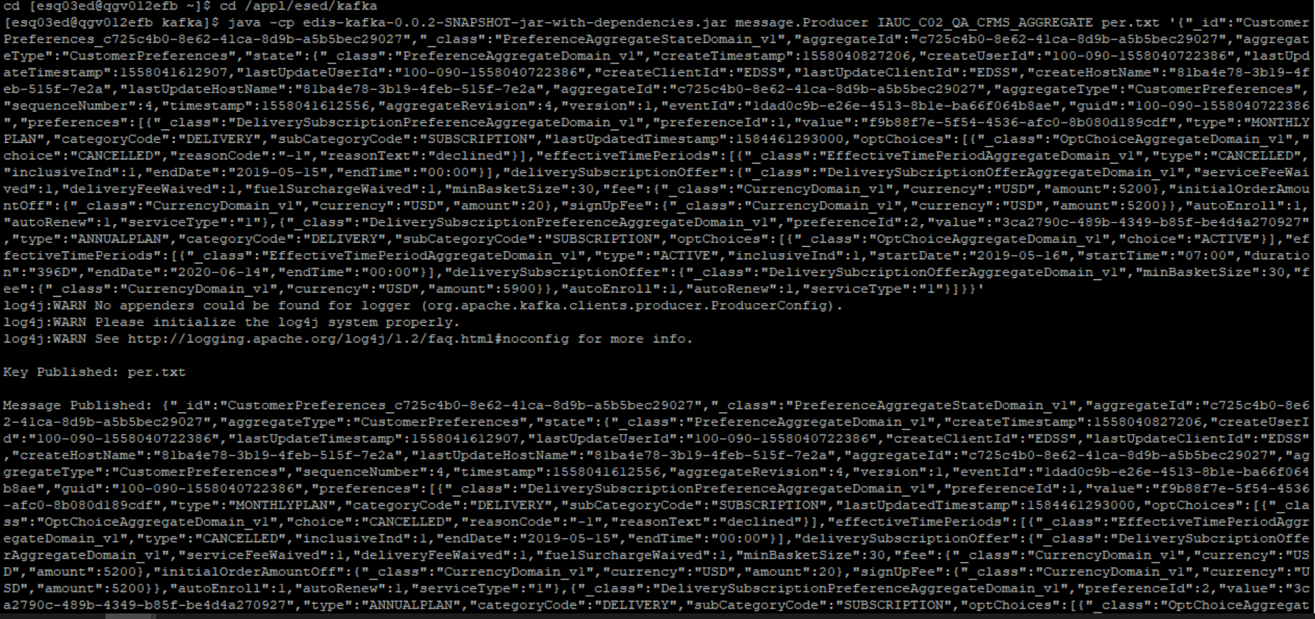



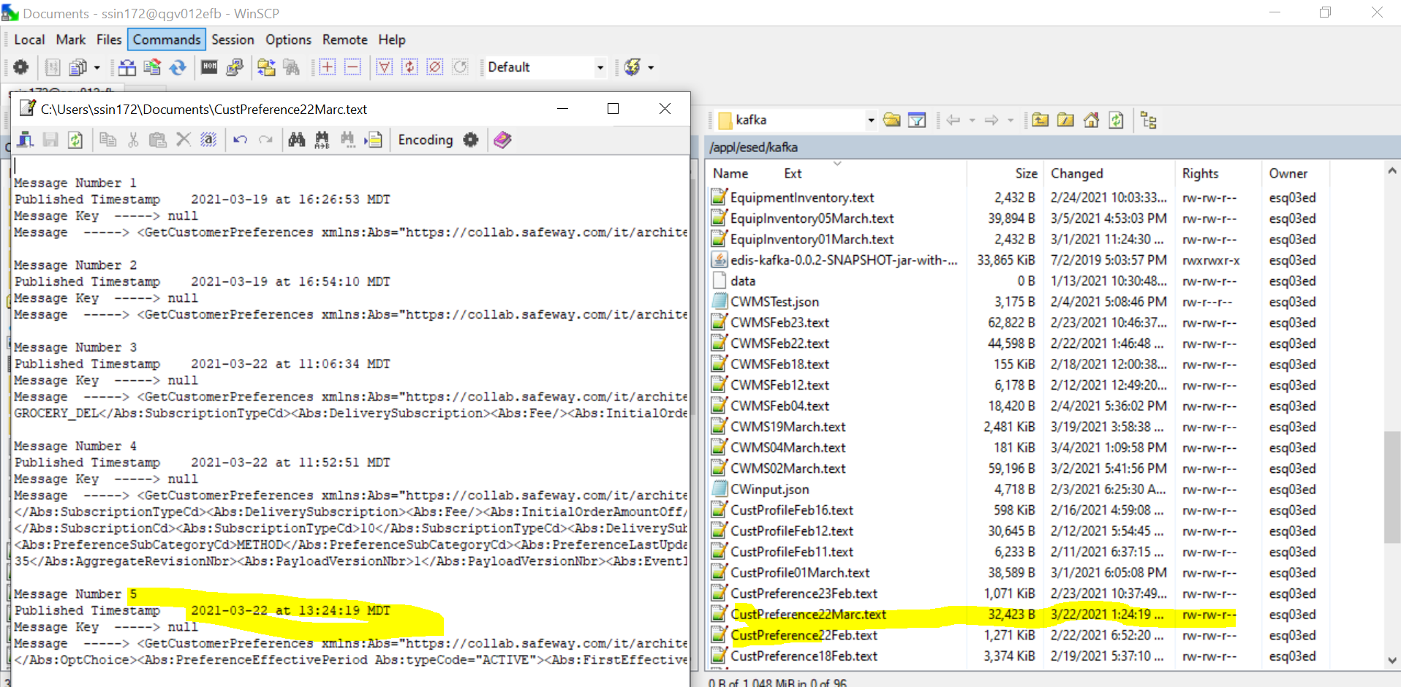

CMM xml-

<GetCustomerPreferences

xmlns:Abs="https://collab.safeway.com/it/architecture/info/default.aspx">

<DocumentData>

<Document VersionId="3.3.1.053" SystemEnvironmentCd="QA">

<Abs:DocumentID>IAUC_C02_QA_CFMS_AGGREGATE</Abs:DocumentID>

<Abs:AlternateDocumentID>IAUC_C02_QA_CFMS_AGGREGATE_1_2211_20210322132419904691</Abs:AlternateDocumentID>

<Abs:InboundOutboundInd>Outbound from Albertsons</Abs:InboundOutboundInd>

<Abs:DocumentNm>GetCustomerPreference</Abs:DocumentNm>

<Abs:CreationDt>2021-03-22T13:24:19.904691</Abs:CreationDt>

<Abs:Description>Retail customer&apos;s generic preferences and the subscriptions</Abs:Description>

<Abs:SourceApplicationCd>CFMS</Abs:SourceApplicationCd>

<Abs:TargetApplicationCd>EDIS</Abs:TargetApplicationCd>

<Abs:InternalFileTransferInd>Y</Abs:InternalFileTransferInd>

<Abs:DataClassification>

<Abs:DataClassificationLevel>

<Abs:Code>Internal</Abs:Code>

</Abs:DataClassificationLevel>

<Abs:BusinessSensitivityLevel>

<Abs:Code>Low</Abs:Code>

</Abs:BusinessSensitivityLevel>

<Abs:PHIdataInd>N</Abs:PHIdataInd>

<Abs:PCIdataInd>N</Abs:PCIdataInd>

<Abs:PIIdataInd>N</Abs:PIIdataInd>

</Abs:DataClassification>

</Document>

<DocumentAction>

<Abs:ActionTypeCd>UPDATE</Abs:ActionTypeCd>

<Abs:RecordTypeCd>CHANGE</Abs:RecordTypeCd>

</DocumentAction>

</DocumentData>

<CustomerPreferencesData>

<Abs:CustomerId>c725c4b0-8e62-41ca-8d9b-a5b5bec29027</Abs:CustomerId>

<Abs:CustomerPreferences>

<Abs:PreferenceClassNm>DeliverySubscriptionPreferenceAggregateDomain_v1</Abs:PreferenceClassNm>

<Abs:PreferenceCd>1</Abs:PreferenceCd>

<Abs:PreferenceTypeCd>MONTHLYPLAN</Abs:PreferenceTypeCd>

<Abs:PreferenceVal>f9b88f7e-5f54-4536-afc0-8b080d189cdf</Abs:PreferenceVal>

<Abs:PreferenceCategoryCd>DELIVERY</Abs:PreferenceCategoryCd>

<Abs:PreferenceSubCategoryCd>SUBSCRIPTION</Abs:PreferenceSubCategoryCd>

<Abs:PreferenceLastUpdatedTs>2020-03-17T16:08:13.000Z</Abs:PreferenceLastUpdatedTs>

<Abs:OptChoice>

<Abs:ChoiceDsc>CANCELLED</Abs:ChoiceDsc>

<Abs:ReasonCd>-1</Abs:ReasonCd>

<Abs:ReasonDsc>declined</Abs:ReasonDsc>

</Abs:OptChoice>

<Abs:PreferenceEffectivePeriod Abs:typeCode="CANCELLED">

<Abs:LastEffectiveDt>2019-05-15</Abs:LastEffectiveDt>

<Abs:LastEffectiveTm>00:00:00.000</Abs:LastEffectiveTm>

<Abs:InclusiveInd>1</Abs:InclusiveInd>

</Abs:PreferenceEffectivePeriod>

<Abs:CustomerSubscriptions>

<Abs:SubscriptionId>f9b88f7e-5f54-4536-afc0-8b080d189cdf</Abs:SubscriptionId>

<Abs:SubscriptionCd>SUBSCRIPTION</Abs:SubscriptionCd>

<Abs:SubscriptionTypeCd>MONTHLYPLAN</Abs:SubscriptionTypeCd>

<Abs:DeliverySubscription>

<Abs:Fee CurrencyCd="USD" FeeAmt="5200.00"/>

<Abs:ServiceFeeWaivedInd>1</Abs:ServiceFeeWaivedInd>

<Abs:DeliveryFeeWaivedInd>1</Abs:DeliveryFeeWaivedInd>

<Abs:FuelSurchargeWaivedInd>1</Abs:FuelSurchargeWaivedInd>

<Abs:MinimumBasketSizeQty>30</Abs:MinimumBasketSizeQty>

<Abs:AutoRenewInd>1</Abs:AutoRenewInd>

<Abs:AutoEnrollInd>1</Abs:AutoEnrollInd>

<Abs:InitialOrderAmountOff CurrencyCd="USD" DiscountAmt="20.00"/>

<Abs:SignupFee CurrencyCd="USD" FeeAmt="5200.00"/>

</Abs:DeliverySubscription>

</Abs:CustomerSubscriptions>

</Abs:CustomerPreferences>

<Abs:CustomerPreferences>

<Abs:PreferenceClassNm>DeliverySubscriptionPreferenceAggregateDomain_v1</Abs:PreferenceClassNm>

<Abs:PreferenceCd>2</Abs:PreferenceCd>

<Abs:PreferenceTypeCd>ANNUALPLAN</Abs:PreferenceTypeCd>

<Abs:PreferenceVal>3ca2790c-489b-4349-b85f-be4d4a270927</Abs:PreferenceVal>

<Abs:PreferenceCategoryCd>DELIVERY</Abs:PreferenceCategoryCd>

<Abs:PreferenceSubCategoryCd>SUBSCRIPTION</Abs:PreferenceSubCategoryCd>

<Abs:OptChoice>

<Abs:ChoiceDsc>ACTIVE</Abs:ChoiceDsc>

</Abs:OptChoice>

<Abs:PreferenceEffectivePeriod Abs:typeCode="ACTIVE">

<Abs:FirstEffectiveDt>2019-05-16</Abs:FirstEffectiveDt>

<Abs:FirstEffectiveTm>07:00:00.000</Abs:FirstEffectiveTm>

<Abs:LastEffectiveDt>2020-06-14</Abs:LastEffectiveDt>

<Abs:LastEffectiveTm>00:00:00.000</Abs:LastEffectiveTm>

<Abs:DurationNbr>396</Abs:DurationNbr>

<Abs:DurationUnitDsc>Days</Abs:DurationUnitDsc>

<Abs:InclusiveInd>1</Abs:InclusiveInd>

</Abs:PreferenceEffectivePeriod>

<Abs:CustomerSubscriptions>

<Abs:SubscriptionId>3ca2790c-489b-4349-b85f-be4d4a270927</Abs:SubscriptionId>

<Abs:SubscriptionCd>SUBSCRIPTION</Abs:SubscriptionCd>

<Abs:SubscriptionTypeCd>ANNUALPLAN</Abs:SubscriptionTypeCd>

<Abs:DeliverySubscription>

<Abs:Fee CurrencyCd="USD" FeeAmt="5900.00"/>

<Abs:MinimumBasketSizeQty>30</Abs:MinimumBasketSizeQty>

<Abs:AutoRenewInd>1</Abs:AutoRenewInd>

<Abs:AutoEnrollInd>1</Abs:AutoEnrollInd>

<Abs:InitialOrderAmountOff/>

<Abs:SignupFee/>

</Abs:DeliverySubscription>

</Abs:CustomerSubscriptions>

</Abs:CustomerPreferences>

<Abs:SourceAuditData>

<Abs:SourceNm>CustomerPreferences</Abs:SourceNm>

<Abs:CreateTs>2019-05-16T21:07:07.206Z</Abs:CreateTs>

<Abs:LastUpdateTs>2019-05-16T21:20:12.907Z</Abs:LastUpdateTs>

<Abs:CreateClientId>EDSS</Abs:CreateClientId>

<Abs:CreateUserId>100-090-1558040722386</Abs:CreateUserId>

<Abs:LastUpdateClientId>EDSS</Abs:LastUpdateClientId>

<Abs:LastUpdateUserId>100-090-1558040722386</Abs:LastUpdateUserId>

<Abs:CreateHostNm>81ba4e78-3b19-4feb-515f-7e2a</Abs:CreateHostNm>

<Abs:LastUpdateHostNm>81ba4e78-3b19-4feb-515f-7e2a</Abs:LastUpdateHostNm>

<Abs:SequenceNbr>4</Abs:SequenceNbr>

<Abs:AggregateTs>2019-05-16T21:20:12.556Z</Abs:AggregateTs>

<Abs:AggregateRevisionNbr>4</Abs:AggregateRevisionNbr>

<Abs:PayloadVersionNbr>1</Abs:PayloadVersionNbr>

<Abs:EventId>1dad0c9b-e26e-4513-8b1e-ba66f064b8ae</Abs:EventId>

</Abs:SourceAuditData>

</CustomerPreferencesData>

</GetCustomerPreferences>